Project Design Phase-II
Technology Stack (Architecture & Stack)

Date | 28 June 2026
Team ID
Project Name | Plugging into the Future: An Exploration of Electricity Consumption Patterns
Maximum Marks | 4 Marks

Technical Architecture:
The Deliverable shall include the architectural diagram as below and the information as per the table1 & table 2
Example: Order processing during pandemics for offline mode
Reference: https://developer.ibm.com/patterns/ai-powered-backend-system-for-order-processing-during-pandemics/

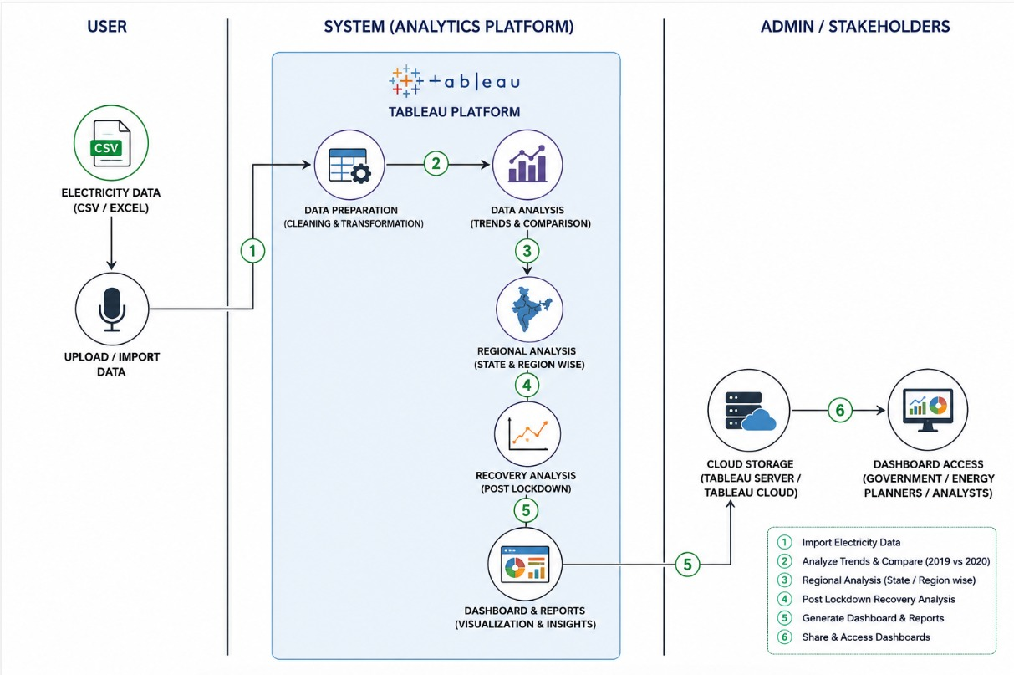
Table-1 : Components & Technologies:
S.No | Component | Description | Technology
1 | Data Source | Stores electricity consumption data for Indian states | CSV/Excel
2 | Data Preparation | Cleans and transforms the dataset | Microsoft Excel
3 | Data Analysis | Performs trend and regional analysis | Tableau
4 | Visualization | Creates charts, maps, and dashboards | Tableau
5 | Reporting | Generates reports and insights | Tableau, MS Word
6 | Presentation | Presents project findings | Microsoft PowerPoint

Table-2: Application Characteristics:
S.No | Characteristics | Description | Technology
 | Platform | Desktop-based analytics application | Tableau Desktop
 | Data Type | Structured data | CSV/Excel
 | User Interface | Interactive dashboard with filters and charts | Tableau
 | Data Processing | Cleaning and preprocessing of data | Microsoft Excel
 | Reporting | Generation of analytical reports | Tableau & MS Word
 | Accessibility | Dashboard can be shared with stakeholders | Tableau Public/Desktop

